<http://java67.blogspot.com.by/2013/04/10-frequently-asked-sql-query-interview-questions-answers-database.html>

10 Frequently asked SQL Query Interview Questions

In this article I am giving some examples of SQL queries which is frequently asked when you go for a programming interview, having one or two year experience on this field .Whether you go for Java developer position or any other technology programmer position, may interviewer expect you to answer basic questions from Database and SQL. It's also obvious that if you are working from one or two years on any project there is good chance that you come across to handle database, writing SQL queries to insert, update, delete and select records. One simple but effective way to check candidate's SQL skill is by asking these types of simple query. They are are neither very complex nor very big, but yet they cover all key concept a programmer should know about SQL. These queries test your SQL skill on Joins, both INNER and OUTER join, filtering records by using [WHERE and HAVING clause](http://javarevisited.blogspot.sg/2013/08/difference-between-where-vs-having-clause-SQL-databse-group-by-comparision.html), grouping records using GROUP BY clause, calculating sum, average and counting records using aggregate function like AVG(), SUM() and COUNT(), searching records using wildcards in LIKE operator, searching records in a bound using BETWEEN and IN clause, DATE and TIME queries etc. If you have faced any interesting SQL query or you have any problem and searching for solution, you can post it here for everyone's benefit. If you are looking for more challenging SQL query exercises and puzzles then you can also check [Joe Cleko's SQL Puzzles And Answers](http://www.amazon.com/Puzzles-Answers-Edition-Kaufmann-Management/dp/0123735963?tag=javamysqlanta-20), one of the best book to really check and improve your SQL skills.

## SQL Query Interview Questions and Answers

**Question 1: SQL Query to find second highest salary of Employee**

Answer : There are many ways to find second highest salary of Employee in SQL, you can either use SQL Join or Subquery to solve this problem. Here is SQL query using Subquery :

select MAX(Salary) from Employee WHERE Salary NOT IN (select MAX(Salary) from Employee );

See [How to find second highest salary in SQL](http://javarevisited.blogspot.com/2012/12/how-to-find-second-highest-or-maximum-salary-sql.html) for more ways to solve this problem.

**Question 2: SQL Query to find Max Salary from each department.**

Answer : You can find maximum salary for each department by grouping all records by DeptId and then using MAX() function to calculate maximum salary in each group or each department.

SELECT DeptID, MAX(Salary) FROM Employee GROUP BY DeptID.

This questions become more interesting if Interviewer will ask you to print department name instead of department id, in that case you need to join Employee table with Department using foreign key DeptID, make sure you do LEFT or RIGHT OUTER JOIN to include departments without any employee as well.  Here is the query

SELECT DeptName, MAX(Salary) FROM Employee e RIGHT JOIN Department d ON e.DeptId = d.DeptID GROUP BY DeptName;

In this query we have use RIGHT OUTER JOIN because we need name of department from Department table which is on right side of JOIN clause, even if there is no reference of dept_id on Employee table.  **Question 3: Write SQL Query to display current date.**

Answer : SQL has built in function called GetDate() which returns current timestamp. This will work in Microsoft SQL Server, other vendors like Oracle and MySQL also has equivalent functions.

SELECT GetDate();

**Question 4: Write an SQL Query to check whether date passed to Query is date of given format or not**.

Answer : SQL has IsDate() function which is used to check passed value is date or not of specified format ,it returns 1(true) or 0(false) accordingly. Remember ISDATE() is a MSSQL function and it may not work on Oracle, MySQL or any other database but there would be something similar.

SELECT ISDATE('1/08/13') AS "MM/DD/YY";

It will return 0 because passed date is not in correct format.

**Question 5: Write a SQL Query to print the name of distinct employee whose DOB is between 01/01/1960 to 31/12/1975.**

Answer : This SQL query is tricky but you can use BETWEEN clause to get all records whose date fall between two dates.

SELECT DISTINCT EmpName FROM Employees WHERE DOB BETWEEN ‘01/01/1960’ AND ‘31/12/1975’;

**Question 6: Write an SQL Query find number of employees according to gender whose DOB is between 01/01/1960 to 31/12/1975.**

Answer : 

SELECT COUNT(*), sex from Employees WHERE DOB BETWEEN '01/01/1960' AND '31/12/1975' GROUP BY sex;

**Question 7: Write an SQL Query to find employee whose Salary is equal or greater than 10000**.

Answer : 

SELECT EmpName FROM Employees WHERE Salary>=10000;

**Question 8: Write an SQL Query to find name of employee whose name Start with ‘M’**

Answer : 

SELECT * FROM Employees WHERE EmpName like 'M%';

**Question 9: find all Employee records containing the word "Joe", regardless of whether it was stored as JOE, Joe, or joe.**

Answer :

SELECT * from Employees WHERE UPPER(EmpName) like '%JOE%';

**Question 10: Write a SQL Query to find year from date.**

Answer :  Here is how you can find Year from a Date in SQL Server 2008 

SELECT YEAR(GETDATE()) as "Year";

**Question 11 : Write SQL Query to find duplicate rows in a database? and then write SQL query to delete them?**  
Answer : You can use following query to select distinct records :

SELECT * FROM emp a WHERE rowid = (SELECT MAX(rowid) FROM EMP b WHERE a.empno=b.empno)

to Delete:

DELETE FROM emp a WHERE rowid != (SELECT MAX(rowid) FROM emp b WHERE a.empno=b.empno);

**Question 12 : There is a table which contains two column Student and Marks, you need to find all the students, whose marks are greater than average marks i.e. list of above average students.**  
Answer : This query can be written using sub query as shown below :

SELECT student, marks from table where marks > SELECT AVG(marks) from table)

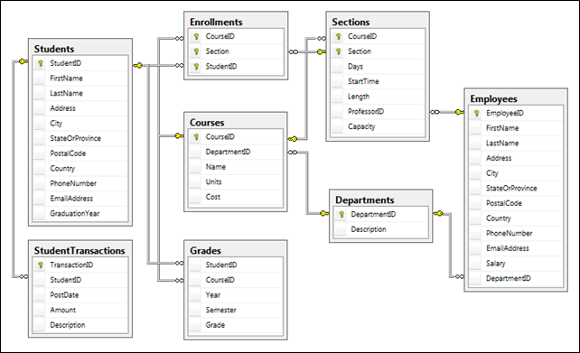

**Question 13 : How do you find all employees which are also manager? .**  
You have given an standard employee table with an additional column mgr_id, which contains employee id of manager.

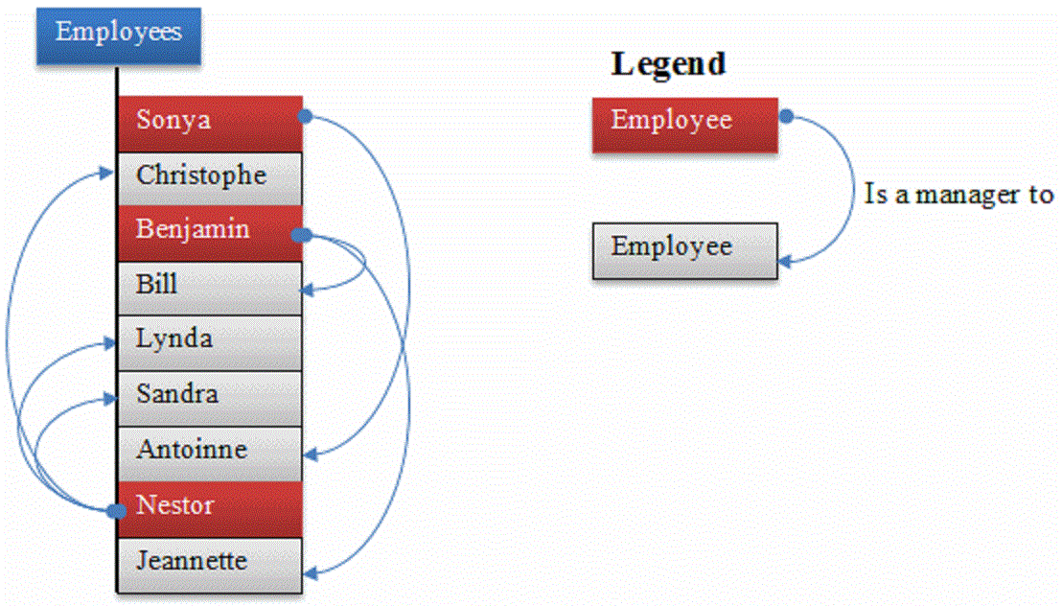

Answer : You need to know about self join to solve this problem. In Self Join, you can join two instances of same table to find out additional details as shown below

SELECT e.name, m.name FROM Employee e, Employee m WHERE e.mgr_id = m.emp_id;

this will show employee name and manger name in two column e.g.  
  
name  manager_name  
John   David  
  
One follow-up is to modify this query to include employees which doesn't have manager. To solve that, instead of using inner join, just use left outer join, this will also include employees without managers.  
  
  
  
**Question 14 : You have a composite index of three columns, and you only provide value of two columns in WHERE clause of a select query? Will Index be used for this operation?** For example if Index is on EmpId, EmpFirstName and EmpSecondName and you write query like

SELECT * FROM Employee WHERE EmpId=2 and EmpFirstName='Radhe'

If the given two columns are secondary index column then index will not invoke, but if the given 2 columns contain primary index(first col while creating index) then index will invoke. In this case Index will be used because EmpId and EmpFirstName are primary columns.

Hope this article will help you to take a quick practice whenever you are going to attend any interview and not have much time to go into the deep of each query.

Other Interview Questions posts from Java67 Blog

* [10 Tricky Java Interview Questions](http://java67.blogspot.sg/2012/09/top-10-tricky-java-interview-questions-answers.html)
* [10 Java Web Service Interview questions](http://java67.blogspot.sg/2012/09/top-10-java-web-service-interview-question-answer-soap-rest.html)
* [10 Android Interview Questions](http://java67.blogspot.sg/2012/10/top-10-android-interview-questions-and.html)
* [10 Java Collection and Generics interview questions](http://java67.blogspot.sg/2012/09/java-collection-interview-questions.html)
* [10 JDBC Interview Questions in Java](http://java67.blogspot.sg/2012/12/jdbc-interview-questions-answers-in-Java-2-4-years-experienced.html)

***************************************